IMG_256

### **[点微]同城红包**

[点微]同城提供发送红包功能

**红包百度AK 申请设置**

**第一步：打开右边说明申请地址**

[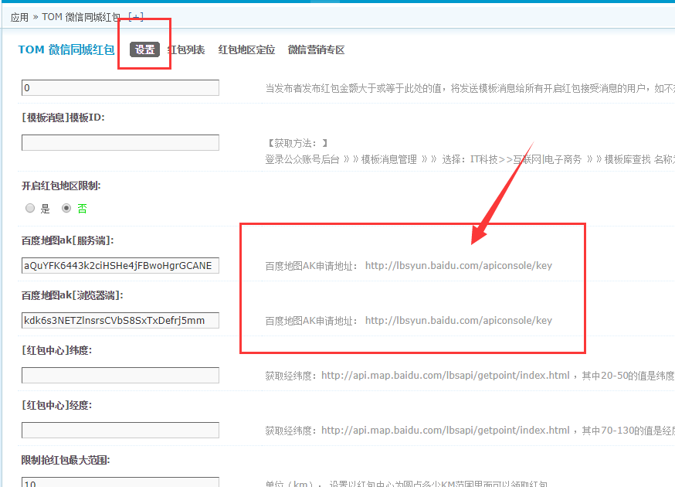](http://www.tomwx.cn/source/plugin/tom_editor/editor/attached/image/20170915/20170915023054_58534.png)

**第二步：链接登录后，点击创建应用按钮**

[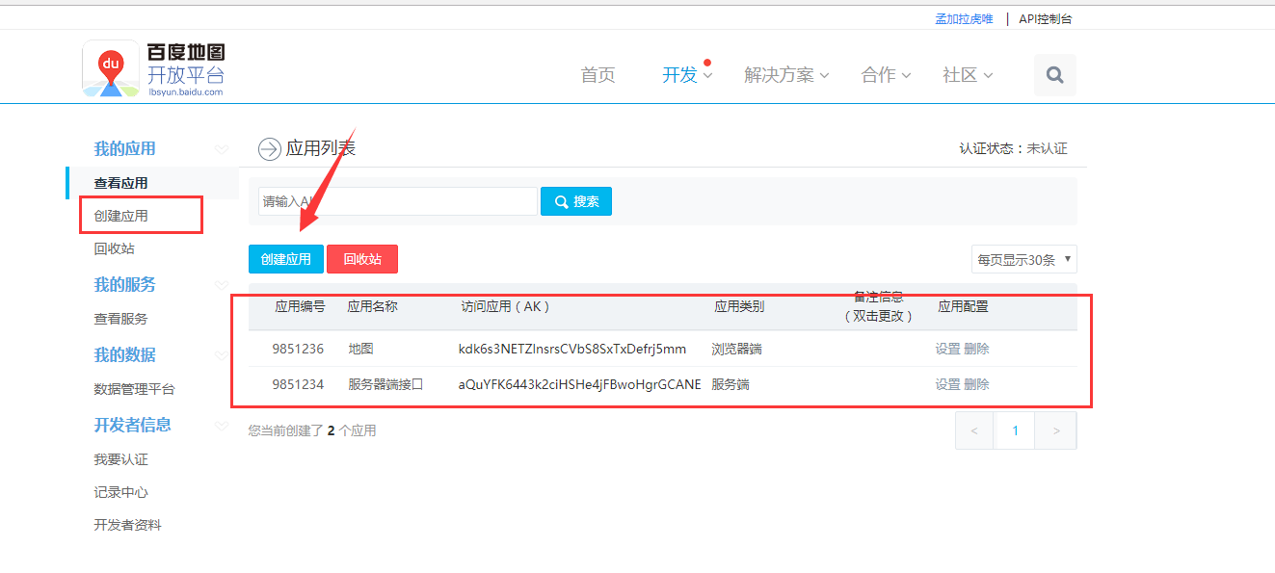](http://www.tomwx.cn/source/plugin/tom_editor/editor/attached/image/20170914/20170914121030_83364.png)

**第三步：添加的两个应用，分别按照以下截图设置**

**第一个：**

[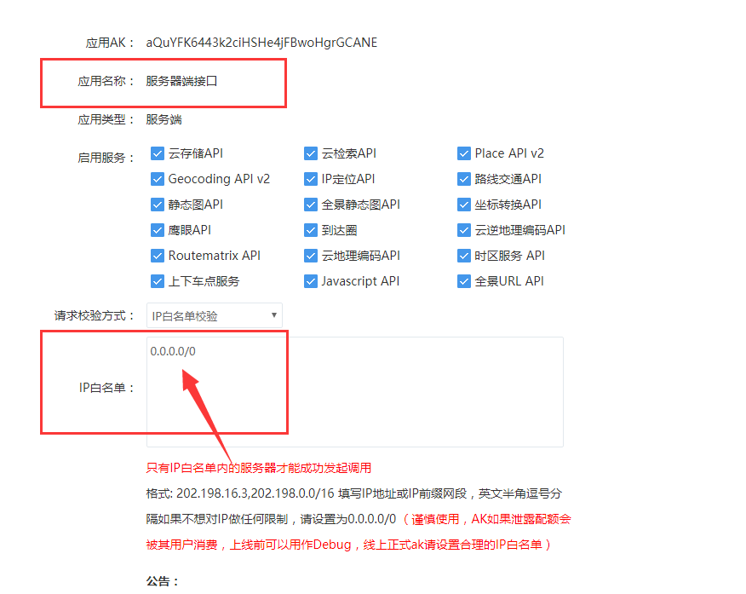](http://www.tomwx.cn/source/plugin/tom_editor/editor/attached/image/20170914/20170914121520_39048.png)

**第二个：**

[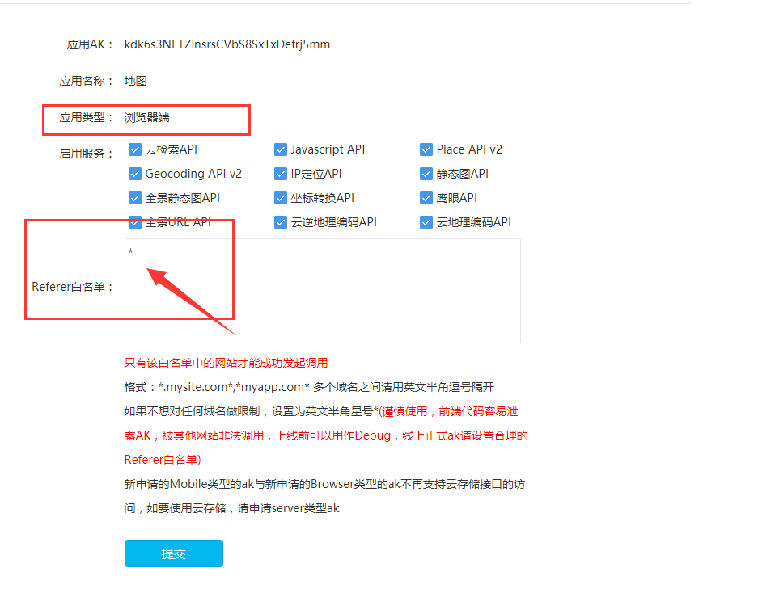](http://www.tomwx.cn/source/plugin/tom_editor/editor/attached/image/20170914/20170914121553_91663.png)

**最后一步：把添加好生成的两个应用百度AK复制粘贴到好店后台设置**

[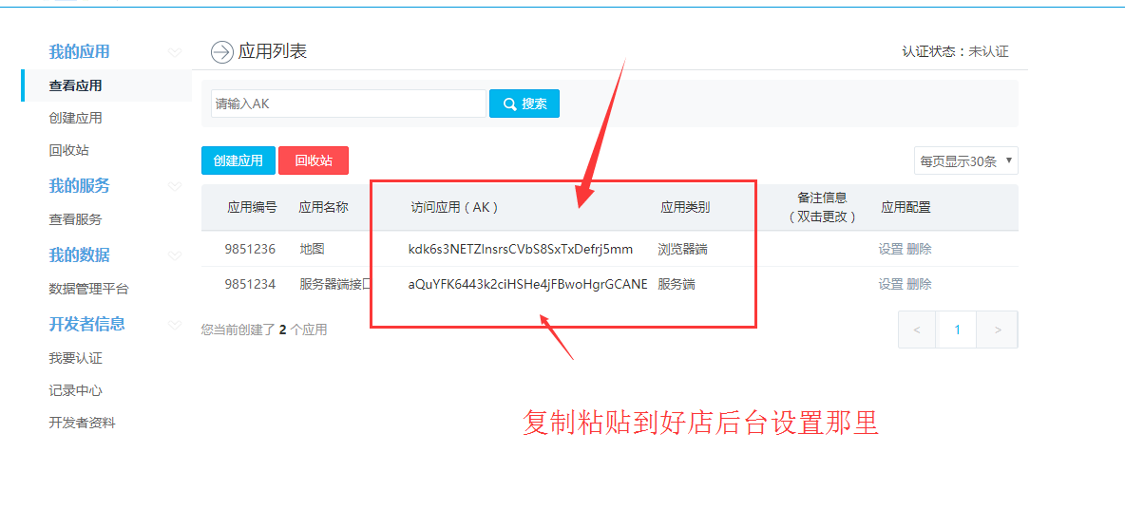](http://www.tomwx.cn/source/plugin/tom_editor/editor/attached/image/20170914/20170914122013_20818.png)

**粘贴到这个位置：**

[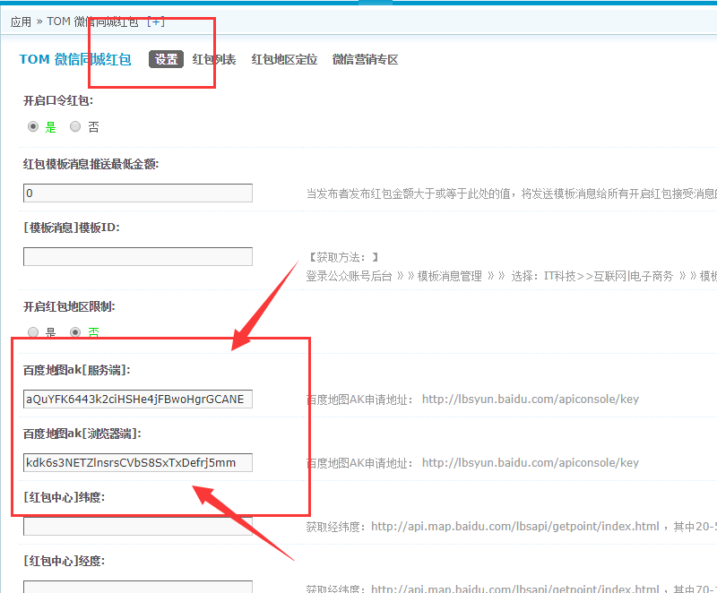](http://www.tomwx.cn/source/plugin/tom_editor/editor/attached/image/20170915/20170915023125_36829.png)